1. Input:

#include<stdio.h>

#include<conio.h>

void main()

{

char a;

clrscr();

a='\a';

printf("\n The ASCII value of '\\a' is: %d",a);

a='\b';

printf("\n The ASCII value of '\\b' is: %d",a);

a='\f';

printf("\n The ASCII value of '\\f' is: %d",a);

a='\n';

printf("\n The ASCII value of '\\n' is: %d",a);

a='\r';

printf("\n The ASCII value of '\\r' is: %d",a);

a='\t';

printf("\n The ASCII value of '\\t' is: %d",a);

a='\v';

printf("\n The ASCII value of '\\v' is: %d",a);

a='\?';

printf("\n The ASCII value of '\\?' is: %d",a);

a='\\';

printf("\n The ASCII value of '\\\\' is: %d",a);

getch(); }

Output: 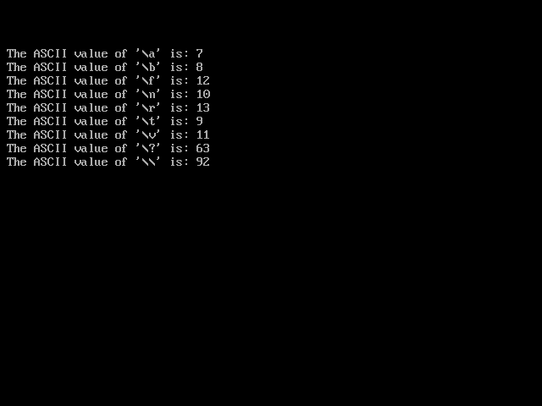

C has a concept of 'data types' which are used to define a variable before its use. The definition of a variable will assign storage for the variable and define the type of data that will be held in the location.

The value of a variable can be changed any time.

C has the following basic built-in datatypes.

* int
* float
* double
* char

**int** is used to define integer numbers.

**{**

**Int number;**

**Number=5;**

**}**

**float** is used to define floating point numbers.

**{**

**Float Miles;**

**Miles=5.6;**

**}**

**double** is used to define BIG floating point numbers.

**{**

**Double Atoms;**

**Atoms=250000;**

**}**

**char** defines characters.

**{**

**Character Letter;**

**Letter=’x’;**

**}**

1. In a passage of text invidual words and punctuation marks are called **“Tokens”.** Similarly in C program the smallest individual units are known as **C tokens.**

C has a 6 types of tokens:

Keywords , Identifiers , Constants , String , Special Symbols and Operators.

(1)Keywords and Identifiers : Every C word is classified as either keyword or identifier and have fix meaning and meanings cannot be change. All key must be written in lower case.Identifiers refers to names of variable function and Arrays .Both upper case, Lower case and underscore are permitted.

(2) Constants : It refers to the fix value that does not change during execution of program. Constant are of two types: (a) Numeric and (b) character.

(3)String Constant : It is a sequence of character enclosed in double quotes.

1. Backslash Character : They are used in output function example

\b Backspace

\f Form feed

\n New line

\r Carriage return

\t Horizontal tab

\" Double quote

\' Single quote

\\ Backslash

\v Vertical tab

\a Alert(very small sound)

\? Question mark

\N Octal constant (N is an octal constant)

\xN Hexadecimal constant (N is an hexadecimal constant).